Chapter 12: Options on Futures

Questions and Problems

- Use the following data from January 31 of a particular year for a group of March 480 options on futures contract to answer parts a through g.
________________________________________________________

Futures price: 483.10
Expiration: March 18
Risk-free rate: .0284 percent (simple)
Call price: 6.95
Put price: 5.25
________________________________________________________

The option’s life is January 31 to March 18, so
T = 46/365 = .1260

- Determine the intrinsic value of the call.

Intrinsic Value = Max (0, f - E)
= Max (0, 483.10 – 480)

- Determine the time value of the call.

Time Value = Call Price – Intrinsic Value
= 6.95 – 3.10
= 3.85

- Determine the lower bound of the call.

Lower Bound = Max [0, (f – E) (1 + r^{)-T}]
= Max [0, (483.10 – 480) (1.0284)^{-.1260}]
= 3.09

- Determine the intrinsic value of the put.

= Max (0, E – f)
= Max (0, 480 – 483.10
= 0

- Determine the time value of the put.

= Put Price – Intrinsic Value
= 5.25 – 0
= 5.25
- Determine the lower bound of the put.

= Max [0, (E – f) (1 + r)^{-T}]
= Max [0, (480 – 483.10) (1.0284)^{-.1260}]
= 0
(Note: the lower bound applies only to European puts.)

- Determine whether put-call parity holds.

C = P + (f – E) (1 + r)^{-T}
= 5.25 + (483.10 – 480) (1.0284)^{-.1260}
= 8.34
The actual call price is 6.95, so put-call parity does not hold.

- The put-call parity rule can be expresses C – P = (f-E) (1+r)^{-T}. Consider the following data: f = 102, E = 100, r = .1, T = .25, C = 4, and P = 1.75. A few calculations will show that the prices do not conform to the rule. Suggest an arbitrage strategy and show how it can be used to capture a risk-free profit. Assume no transaction costs. Be sure your answer shows the payoffs at expiration and proves these payoffs are riskless.

(f – E) (1 + r)^{-T} = (102 – 100) (1.10)⁻²⁵ = 1.95
C – P = 4 – 1.75 = 2.25

C – P is too high so the call is overpriced and/or the put is underpriced (or we could assume the futures is underpriced). So sell the call, buy the put, and buy the futures. At expiration the payoffs will be

Short call 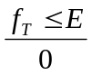 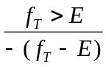
Long put E – f_{T} 0
Long futures 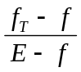

This is equivalent to a risk-free loan, as a lender if E > f or as a borrower if f > E. Here is f > E so you are a borrower. The present value should be (E-f) (1 + r)^{-T} = (102 – 100) (1.10)^{-.25} = 1.95. Thus you sell the call for 4 and buy the put for -1.75 for a net inflow of 2.25. At expiration, you pay back 2.00.

- Explain why American call options on futures could be exercised early when call option on the spot are not. Assume no dividends.

In Chapters 3 and 4 we covered American call options on the spot and explained that in the absence of dividends they will not be exercised early. They will always sell for at least the lower bound, which is higher than the intrinsic value, and usually more. However, call options on the futures may be exercised early. If the price of the underlying instrument is extremely high, the call will begin to behave like the futures, changing almost dollar-for-dollar with the futures price. For an option on the spot, the call will behave like the spot, changing almost one-for-one with the price of the spot. Exercise of the futures call will release funds tied up in the call and provide a position in the futures. Exercise of the call on the spot does not, however, release funds, since the investor has to purchase the spot instrument.

- Assume a standard deviation of .08, and use the Black model to determine if the call option in problem 1 is correctly priced. If not, suggest a riskless hedge strategy.

First find the continuously compounded risk-free rate: r_{c} = ln (1.0284) = .0280. Then price the option:

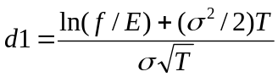
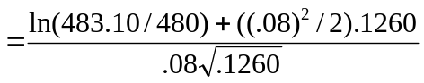
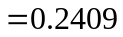
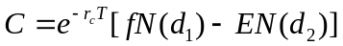

The option appears to be underpriced. You could sell 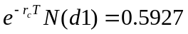 futures and buy one call, adjusting the hedge ratio through time and earn an arbitrage profit.

- Describe two problems in using the Black option on futures pricing model for pricing options on Eurodollar futures.

The Black model is not an American option on futures pricing model and Eurodollar options on futures are American. Also the Black model assumes constant interest rates. Since Eurodollars are interest-sensitive instruments, they violate an assumption of the model.

- Using the information in problem 4, calculate the price of the put described in problem 1 using the Black model for pricing puts.

We already know that N (.24) = .5948 and N (.21) = .5832. Then

- Explain why the futures option pricing model is simply a pricing model for options on instruments with a zero cost of carry.

A spot option pricing model such as Black-Scholes is a model for pricing options on instruments with a cost of carry of r_{c} (or r_{c} - δ if there is a dividend yield).Since a futures requires no outlay of funds not does it incur a storage cost, it has no cost of carry. The cost of carry relevant to the futures price is the cost of carry of the underlying spot instrument. An option on a futures is, therefore, an option on an instrument with a zero cost of carry. The futures option pricing model is the same as the spot option pricing model where the spot price is replaced with the futures price and the cost of carry is zero. The latter is established by assuming a dividend yield equal to the interest rate.

- In Chapter 4, we examined the sensitivity of a call’s price to different risk-free rates and volatilities. Compute the Black option on futures price using the data for the call given in problems 1 and 4 for the following risk-free rates and standard deviations. Use either the Excel spreadsheet bsbin1.xls or the Windows program bsbwin2.exe.
  - Use risk-free rates of 1 through 10 percent in increments of 100 basis points. We know that the call price should increase as we increase r. What do you notice about the results? Try to explain. (Hint: Remember that f=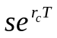.)

Using a bsbin1.xls, we obtain
r_{c}(%) C
- 7.14
- 7.13
- 7.12
- 7.11
- 7.10
- 7.09
- 7.08
- 7.07
- 7.06
- 7.06

Instead of increasing with r_{c}, they slowly decrease. As we increase r_{c}, however, we should be increasing f (since 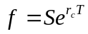). Since we do not increase f, we are implicitly lowering it. This more than offsets the effect of an increase in r_{c}.

  - Use standard deviations of .05 through .50 in increments of .05. Comment on what you find.

    - C
.05 5.16
.10 8.45
.15 11.81
.20 15.19
.25 18.57
.30 21.96
.35 25.34
.40 28.73
.45 32.12
.50 35.50

As with options on the spot, the call price is very sensitive to the volatility.

- An asset worth 100 can go up by 10 percent or down by 7 percent. The risk-free rate is 4 percent. There are options with an exercise price of 100. There are no dividends. Find the values of the following options. Assume two periods until expiration.

The asset can take on the following values:
S_{u} = 100(1.10) = 110
S_{u}² – 110(1.10) = 121
S_{ud} = 100(1.10)(.93) = 102.30
S_{d} = 100(.93) = 93
S_{d}² = 100(.93)(.93) = 86.49

The futures can take on the following prices:
f_{u} = 110(1.04) = 114.40
f_{u}² = 121
f_{ud} = 102.30
f_{d} = 93(1.04) = 96.72
f_{d}² = 86.49
f = 100(1.04)2 = 108.16
These values were obtained by using the cost of carry relationship f = S(1+r)^{#periods remaining}

Because of convergence of the spot to futures prices at expiration, the values at expiration of the calls on the asset and on the futures are
C_{u}² = Max (0,121 – 100) = 21
C_{ud} = Max (0, 102.30 – 100) = 2.30
C_{d}² = Max (0, 86.49 – 100) = 0

The value of p is (.04 – (.07))/(.10 – (-.07)) = .6471.

  - A European call on the asset

The values of the call at end of the first period are
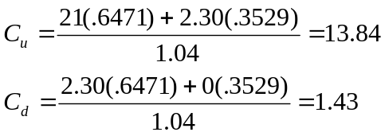
The value of the call today is
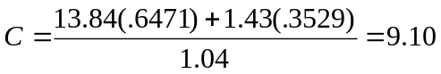

  - An American call on the asset

Since there are no dividends on the asset, an American call will have the same value as the European call, as given in a.

  - A European call on the futures

Since the European option on the futures expires the same time as the European option on the spot, it will have the same value. Thus, the answer is the same as in a.

  - An American call on the futures

At time 1, the American option on the futures can be exercised for a value of Max (0,114.40 – 100) = 14.40 when the futures is at 114.40 and the asset is at 110. This is more than the 13.84 value it would have if it were kept alive. If the futures were at 96.72, with the asset at 93, it would not pay to exercise it early. Therefore, the value today of an American option on futures is

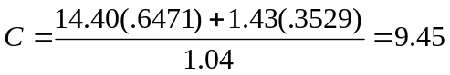

However, we must also check to determine if it is optimal to exercise it immediately. The futures price is currently at 108.16. If the option were exercised, it would be worth only Max (0, 108.16 – 100) = 8.16. thus, it is worth more alive and its value is 9.45.

- Find the implied volatility, to three decimal places, of the call in problem 4 if the call is worth 7.25. Use either the Excel spreadsheet bsbin1.xls or the Windows program bsbwin2.exe.

At σ = .082, the Black call price is 7.25 so .082 is the implied volatility of the futures price to the third decimal place.

- Evaluate the following statement: “Dividends are relevant to the pricing of the European call options but not to the pricing of European call options on futures. Amazingly enough, this is true even though the two calls will have the same price.”

The effect of dividends is imbedded in the futures price through the formula 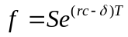. We know that the two calls will have the same price. The effect of the dividend is, thus, reflected in the futures price. It does not enter the model directly so it does not seem relevant to the price of the futures option. However, it does have an indirect effect through the futures price.

Problems 12 through 15 and 17 use some options on futures prices on January 31 of a particular year. Determine the profit form the strategy for each of the following futures prices at expiration: 470, 475, 480, 485, 490, 495. Graph the results. Determine the breakeven futures price at expiration. Use a multiplier of 500.

- The March 485 call price is 4.875. Construct a simple long call position.

C = $4.875 E = 485

Premium = 500($4.875) = $2,437.50

f_{T} | Call Price at Expiration | Profit
470 | 0 | -$2,437.50
475 | 0 | -$2,437.50
480 | 0 | -$2,437.50
485 | 0 | -$2,437.50
490 | 5 | $62.50
495 | 10 | $2,562.50

Futures Price and End of Holding Period
3000

2000

1000

0

-1000
-2000

-3000
Profit ($)
470 475 480 485 490 495

Breakeven: E + C = 485 + 4.875 = 489.875

- The March 485 put price is 6.75. Construct a simple long put position.

P = 6.75 E = 485
Premium = $6.75 (500) = $3,375

f_{T} | Call Price at Expiration | Profit
470 | 15 | $4,125
475 | 10 | $1,625
480 | 5 | -$875
485 | 0 | -$3,375
490 | 0 | -$3,375
495 | 0 | -$3,375

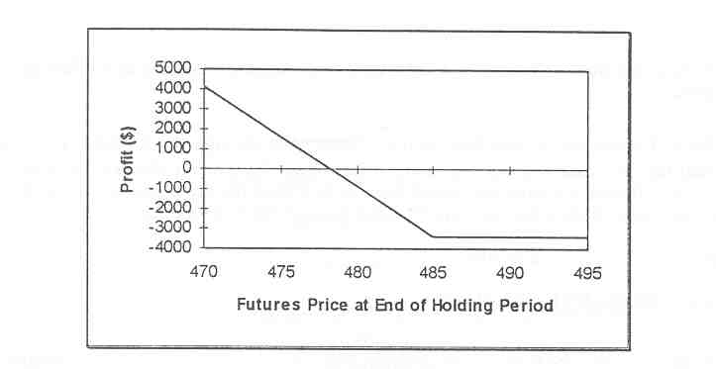

Breakeven: E – P = 485 – 6.75 = 478.25

- The March futures price is 483.10. Using the March call data from problem 12, construct a covered call position.

f = 483.10 C = 4.875 E = 485

The profit from the covered call is given by the following equation

f_{T} | Price Change  on Futures | Call Price  at Expiration | Profit
470 | -13.10 | 0 | -$4,112.50
475 | -8.10 | 0 | -$1,612.50
480 | -3.10 | 0 | $887.50
485 | 1.90 | 0 | $3,387.50
490 | 6.90 | 5 | $3,387.50
495 | 11.90 | 10 | $3,387.50

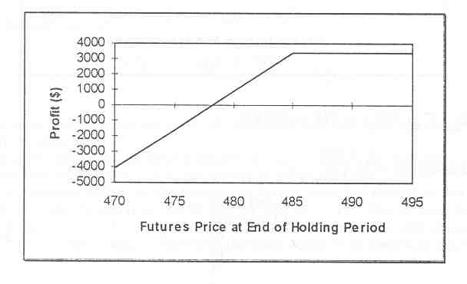
Breakeven: f – C = 483.10 – 4.875 = 478.225

- Using the information in problems 13 and 14, construct a protective put with the March 485 put.

f = 483.10 P = 6.75 E = 485

The profit from a protective put is
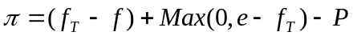

f_{T} | Price Change  on Futures | Put Price  at Expiration | Profit
470 | -13.10 | 15 | -$2,425
475 | -8.10 | 10 | -$2,425
480 | -3.10 | 5 | -$2,425
485 | 1.90 | 0 | -$2,425
490 | 6.90 | 0 | 75
495 | 11.90 | 0 | $2,575

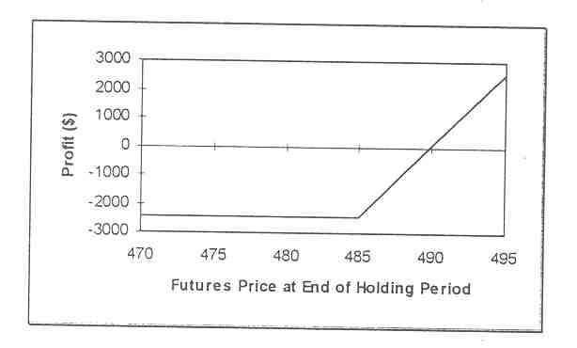
Breakeven: P + f = 6.75 + 483.10 = 489.85

- Discuss why options on futures have advantages not offered by options on the spot.

The underlying instrument for an option on the futures is the futures. The futures contract has more liquidity than the spot instrument. This offers advantages in pricing and trading the option on the futures. Also, for stock indices, it is easier to construct covered calls and protective puts because the futures contract is purchased instead of the spot index. Exercise and delivery are also easier because a futures transaction instead of a spot transaction is involved. Most importantly, however, the option on the futures and its underlying futures contract normally trade side-by-side on the same trading floor, while options on the spot do not. This makes the option attractive to floor traders because arbitrage transactions requiring positions in both the options and the futures can be executed faster and easier.

- (Concept Problem) Redo problem 12, but close the position on March 1. The calls expire March 18. Let σ = .08 and r_{c} = .028. You may wish to use the Excel spreadsheet bsbin1.xls or the Windows program bsbwin2.exe to save time making these calculations.

C = $4.875 E = 485
Premium = 500($4.875) = $2,437.50

f_{T} | Call Price  at Expiration | Profit
470 | 0.11 | -$2,382.50
475 | 0.46 | -$2,207.50
480 | 1.40 | -$1,737.50
485 | 3.34 | -$ 767.50
490 | 6.42 | $ 772.50
495 | 10.48 | $2,802.50

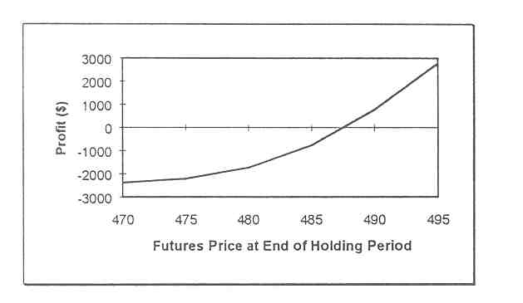
Breakeven: approximately 488

- (Concept Problem) Use the following information to calculate the call option price using the Black model: f = 30, e = 25, r_{c} = .08, σ = .35, and T = .125. Determine the option’s delta. Then recommend a risk-free hedge position, and show why the position is risk free by evaluating its performance if the futures price decreases by $1. Use the Excel spreadsheet bsbin1.xls or the Windows program bsbwin2.exe.

Using the information in the Black model (using the spreadsheet) gives C = 5.05. The delta is . Buy 928 futures and sell 1000 calls. If the futures price falls by $1, you lose $928 on the futures. Each call falls by approximately $0.928 so 1,000 calls fall by $928. You are short the calls, so you gain $928, offsetting the loss on the futures.

The hedge is risk-free only to the extent that the delta accurately measures the change in the option price for a change in the futures price. This will be true if the futures price moves only by a small amount over a short period of time. If it moves by a larger amount, the delta will not accurately reflect the option’s price change. The risk that this will occur is captured by the option’s gamma.

